

Operating Systems

LAB ASESSMENT – 1

Name: **VIBHU KUMAR SINGH**

Reg. No: **19BCE0215**

Teacher: **Manikandan K.**

**Q1) Study of basic Linux commands.**

**A1)**

**TERMINAL:**

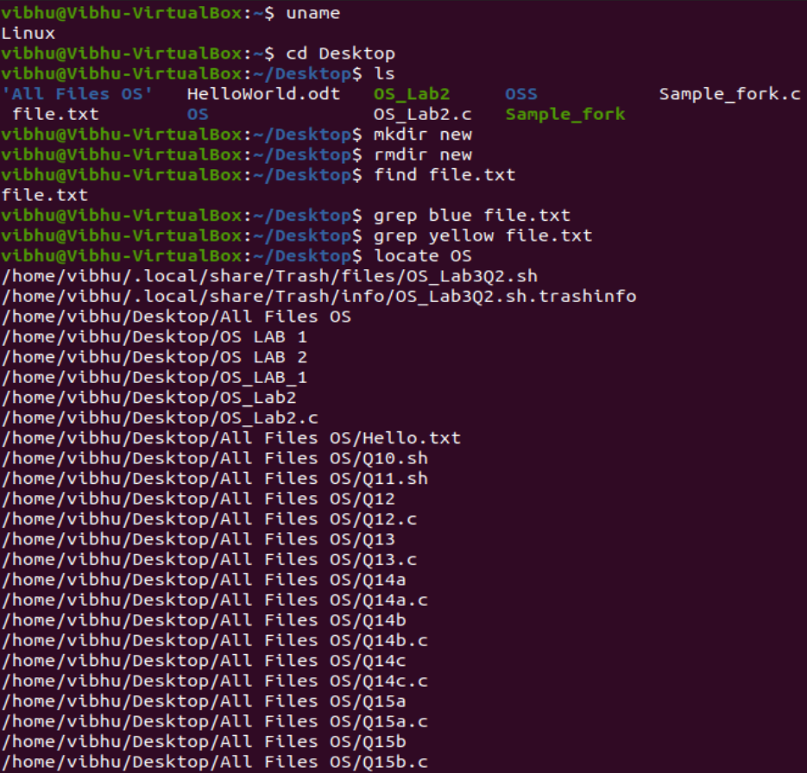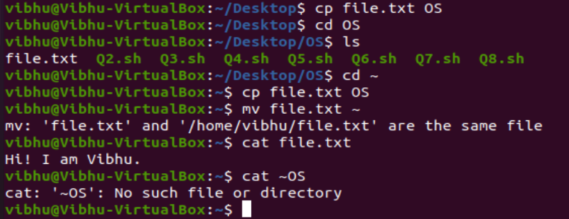

**Q2) Write a shell script to swap two numbers without using 3rd**

**variable.**

**A2)**

**CODE:**

#!/bin/bash

echo -ne "Enter first number: "

read a

echo -ne "Enter second number: "

read b

echo "Before swapping: "

echo " a=$a b=$b"

#swapping

a=$((a+b))

b=$((a-b))

a=$((a-b))

echo "After swapping: "

echo " a=$a b=$b"

**OUTPUT:**

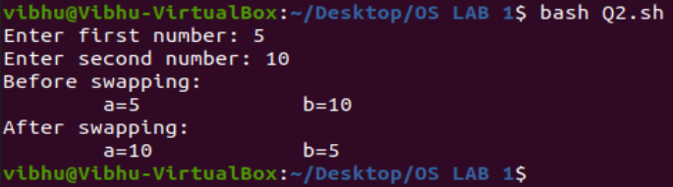

**Q3) Write a shell script using while loop to print the structure.**

**1 0**

**2 1 0**

**3 2 1 0**

**4 3 2 1 0**

**5 4 3 2 1 0**

**6 5 4 3 2 1 0**

**7 6 5 4 3 2 1 0**

**8 7 6 5 4 3 2 1 0**

**9 8 7 6 5 4 3 2 1 0**

**A3**)

**CODE:**

#!/bin/bash

echo -ne "Enter the number of lines: "

read n

for((i=1;i<=n;i++))

do

for((j=i;j>=0;j--))

do

echo -ne "$j"

done

echo;

done

**OUTPUT:**

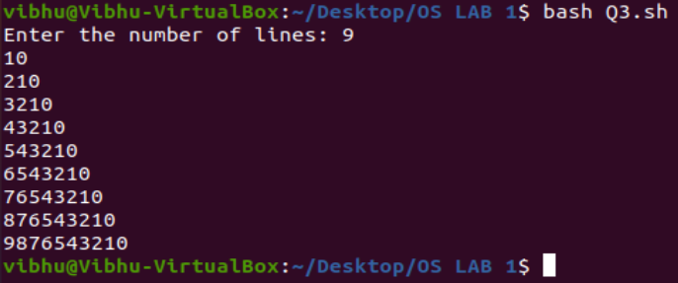

**Q4) Write a shell script to find the sum of first ‘N’ numbers in**

**Fibonacci series (use for loop).**

**A4)**

**CODE:**

#!/bin/bash

echo -ne "Enter the number of terms: "

read n

a=0

b=1

sum=0

for((i=0;i<n;i++))

do

sum=$((sum+a))

fn=$((a+b))

a=$b

b=$fn

done

echo "The sum of first $n terms in the Fibonacci Series is: $sum"

**OUTPUT:**

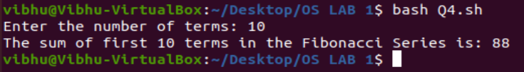

**Q5) Write a shell script to print a given number in reverse order**

**and sum of the individual digits.**

**A5)**

**CODE:**

#!/bin/bash

echo -ne "Enter the number: "

read n

Num=$n

sum=0

echo -ne "The reversed number is: "

while [ $n -gt 0 ]

do

dig=$(( $n % 10 ))

echo -ne "$dig"

n=$(( $n / 10 ))

sum=$(( $sum + $dig ))

done

echo;

echo "The sum of digits of $Num is: $sum"

**OUTPUT:**

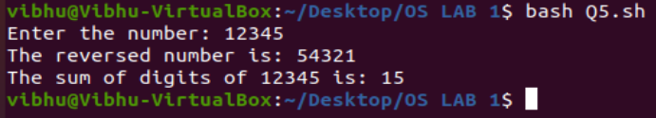

**Q6) Write a shell script to read two strings and display whether it is**

**equal, not equal, null strings or string with special characters.**

**A6)**

**CODE:**

#!/bin/bash

read -p "Enter the first string: " str1

read -p "Enter the second string: " str2

if [ $str1 = $str2 ]

then

echo "The strings are equal."

else

echo "The strings are not equal."

fi

if [ -z $str1 ]

then

echo "The first string is null."

fi

if [ -z $str2 ]

then

echo "The second string is null."

fi

if [[ $str1 =~ ['!@#$%^&*()_+'] ]]

then

echo "The first string contains a special character."

fi

if [[ $str2 =~ ['!@#$%^&*()_+'] ]]

then

echo "The second string contains a special character."

fi

**OUTPUT:**

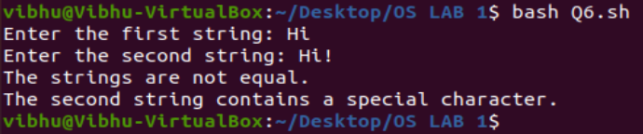

**Q7) Write a shell script to accept one integer argument and print its**

**multiplication table.**

**A7)**

**CODE:**

#!/bin/bash

echo -ne "Enter the Integer: "

read n

echo "The multiplication table for $n is: "

for((i=1;i<=10;i++))

do

result=$(($n * $i))

echo "$n X $i = $result"

done

**OUTPUT:**

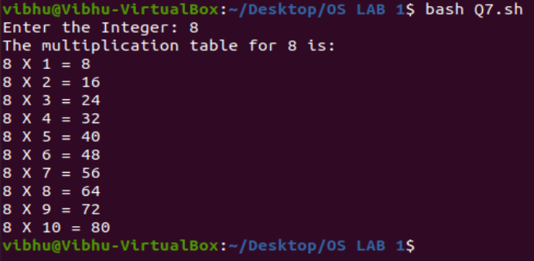

**Q8) Write a Shell Script that makes use of grep to isolate the line in**

**/etc/passwd that contains your login details.**

**A8)**

**CODE:**

#!/bin/bash

grep -F “Vibhu” /etc/passwd

**OUTPUT:**

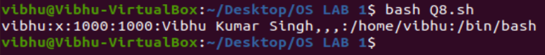

**Q9) Write a shell script to display all files in the**

**/home/YourLoginName subdirectory as well as display the type of all files.**

**A9)**

**CODE:**

#!/bin/bash

echo "File names: "

for File in *

do

if [ -r $File -a -w $File -a -x $File ]

then

echo $File

fi

done

echo;

echo "File types: "

ls -l

**OUTPUT:**

DIRECTORY:

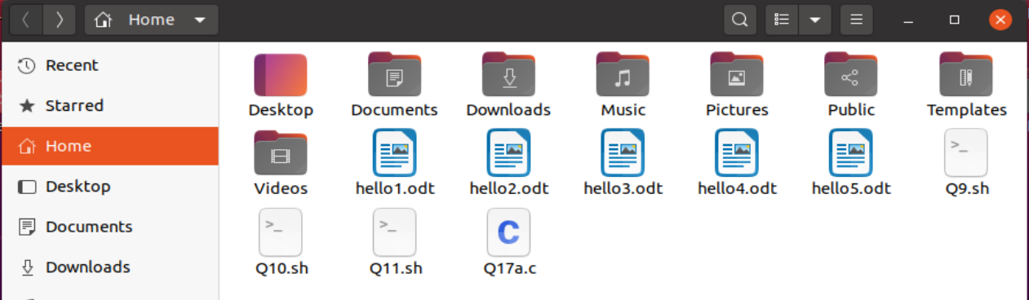

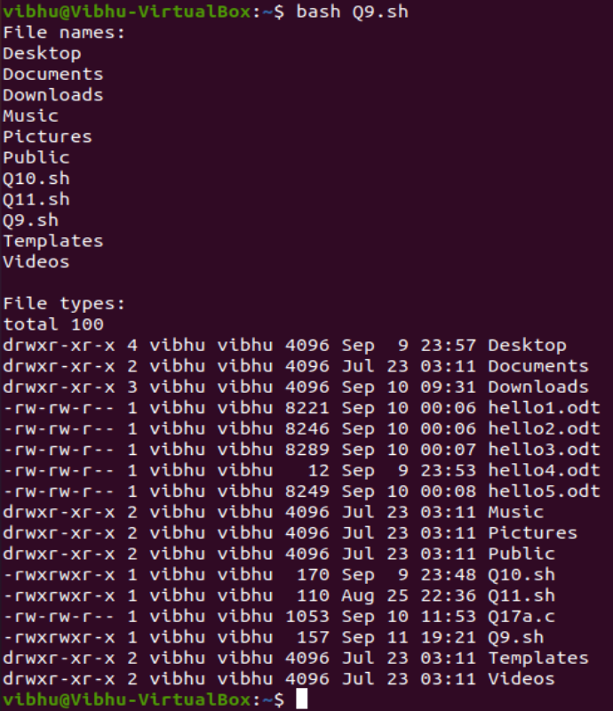

**Q10) Using shell script, display the contents of the present working**

**directory. If it is an ordinary file print its permission and**

**change the permissions to r--r--r—**

**A10)**

**CODE:**

#!/bin/bash/sh

cd Desktop

ls -l

chmod -wr-wr-r "HelloWorld.odt"

chmod +r+r+r "HelloWorld.odt"

ls -l

#changing the file permission of the file named DBMS DA refined 1.odt

**OUTPUT:**

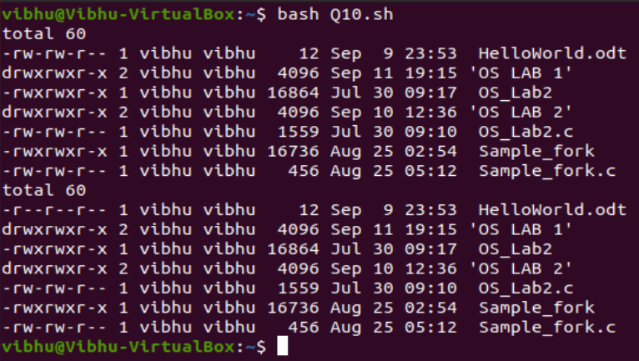

**Q11) Use find, grep and sort to display a sorted list of all files in**

**the /home/YourLoginName subdirectory that contains the**

**word “hello” somewhere inside them.**

**A11)**

**CODE:**

#!/bin/bash/sh

#searching for only odt type for smaller output

find . -name '*' | exec grep -H "hello" | sort

**OUTPUT:**

DIRECTORY:



